Group members
Duku Henry Mugume | 2600726521 | 26/E/26521/PS
Mayen Ayiik Mayen | 2600726534 | 26/E/26534/PS

GitHub link: https://github.com/dukuhenry/Simple-Banking-System
Title: Simple Banking System - CSC 1102 Java Project
Description: A beginner Java Swing desktop application that allows a user to create bank accounts, deposit, withdraw, transfer money, check balances, and view transaction history. No database, no login, no networking. Data is stored in arrays in memory while the program runs. Built using Object-Oriented Programming principles: encapsulation, composition, and separation of duties.

Classes and Purpose
Class | Purpose | Key Attributes / Methods
Customer.java | Stores person details only |  | customerId, fullName, phone |  |  |  |  |  |  |  |  |  |  |  |  |  |  |  | ,
Customer.java | Stores person details only |  | address  toString( | / Getters, Setters, |  |  |  |  |  |  |  |  |  |  |  |  |  |  | ,
 |  |  |  | ) |  |  |  |  |  |  |  |  |  |  |  |  |  |  | ,
Account.java | Stores money + owner, guards balance |  | accountNumber, customer,
Account.java | Stores money + owner, guards balance |  | balance, accountType |  |  |  |  |  |  |  |  |  | /
Account.java | Stores money + owner, guards balance |  | deposit(), withdraw(),
Account.java | Stores money + owner, guards balance |  | getBalance()
Transaction.java | Stores one receipt / history |  | transactionId |  |  |  | ,
Transaction.java | Stores one receipt / history |  | accountNumber, type ,
Transaction.java | Stores one receipt / history |  | amount, date |  |  |  | / Gette rs only,
Transaction.java | Stores one receipt / history |  | no setters
Bank.java | Manager, holds arrays, finds accounts |  | accounts[100] ,
Bank.java | Manager, holds arrays, finds accounts |  | transactions[1000] ,
Bank.java | Manager, holds arrays, finds accounts |  | accountCoun |  |  |  | t /
Bank.java | Manager, holds arrays, finds accounts |  | addAccount(), findAccount() |  |  |  |  |  |  |  |  |  |  |  |  |  |  | ,
Bank.java | Manager, holds arrays, finds accounts |  | deposit(), withdraw(), transfer(), view AllAccounts()
BankSystemGUI.java | Window, buttons, user input |  | JFrame, JPanel, JTextField,
 |  |  | JButton, JTextArea,
 |  |  | JOptionPane |  |  |  | / | ActionListener
 |  |  | for each button, |  |  |  |  |  | main()

How Classes Interact
The GUI does not touch data directly. When a user clicks a button, the GUI reads the text fields and calls a method in Bank. Bank uses findAccount() to search its array with a for loop. If found, Bank asks the Account to deposit() or withdraw(). Account checks the amount with if/else and updates its private balance. If successful, Bank creates a new Transaction object as a receipt and stores it in its transaction array. The GUI then shows a popup or updates the text area.

How To Run + Test Results
To Run: Open the folder in VS Code with Extension Pack for Java. Open BankSystemGUI.java and click Run, or in terminal run javac *.java then java BankSystemGUI
TEST 1 - Create Account
Type: Acc No=101, Name=Duku Henry, Phone=0770000000, Address=Kampala, Amount=1000, Type=Savings
Click: Create Account
Expect: Popup "Account created successfully!" + View shows Acc 101, Balance 1000
Click: Clear
TEST 2 - Deposit
Type: Acc No=101, Amount=500
Click: Deposit
Expect: Popup "Deposit successful!"
Click: Check Balance , Expect: 1500
Click: Clear
TEST 3 - Withdraw
Type: Acc No=101, Amount=200
Click: Withdraw
Expect: Popup "Withdraw successful!"
Click: Check Balance , Expect: 1300
Click: Clear
TEST 4 - Withdraw Too Much (Bad Input Test)
Type: Acc No=101, Amount=5000
Click: Withdraw
Expect: Popup "Withdraw failed!" + Balance still 1300
Click: Clear
TEST 5 - Create Second Account + Transfer
Type: Acc No=102, Name=Mayen Ayiik, Phone=0780000000, Address=Mukono, Amount=0, Type= Click: Create Account
Click: Clear
Type: Acc No=101, To Account=102, Amount=300
Click: Transfer
Expect: Popup "Transfer successful!"
Check Balance 101 , Expect: 1000
Check Balance 102 , Expect: 300
Click: Clear
TEST 6 - View All + View Transactions
Click: View All Accounts , Expect: Both accounts listed in text area
Leave Acc No empty, Click: View Transactions , Expect: All receipts listed
Type: Acc No=101, Click: View Transactions , Expect: Only 101's receipts
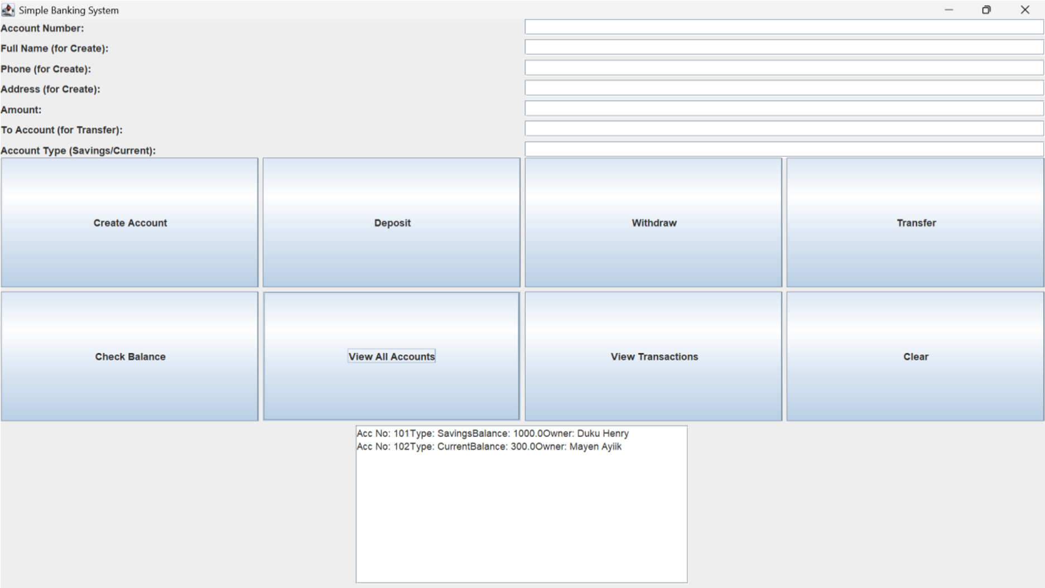
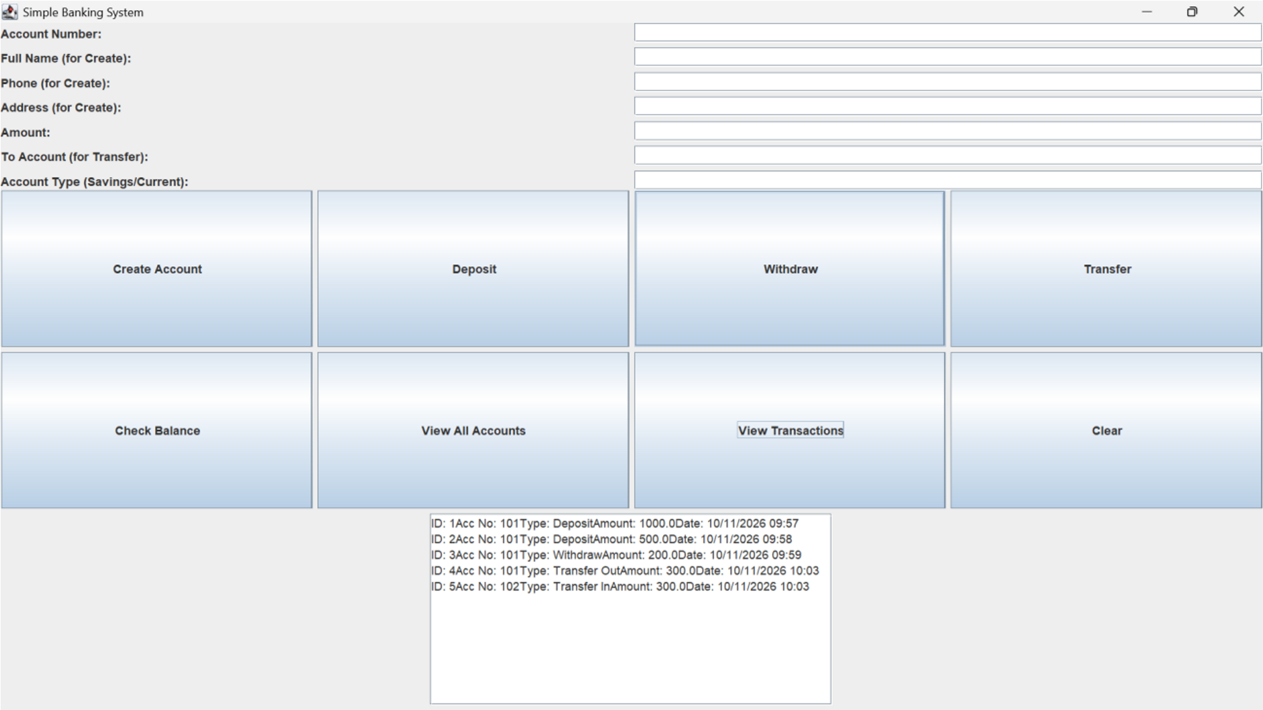
Challenges + Conclusion
Challenges:

- Learning why balance must be private and only changed through methods.
- Understanding accountCount and why loops must stop at accountCount not 100 to avoid empty boxes.
- Handling NumberFormatException so the program does not crash.

Conclusion:
This project taught me OOP in practice: encapsulation protects data, composition lets Account hold a Customer, arrays + loops manage many objects, and Swing lets a GUI talk to logic through one Bank object. The system meets all requirements: Swing only, arrays only, no database, no login.

